Install IIS 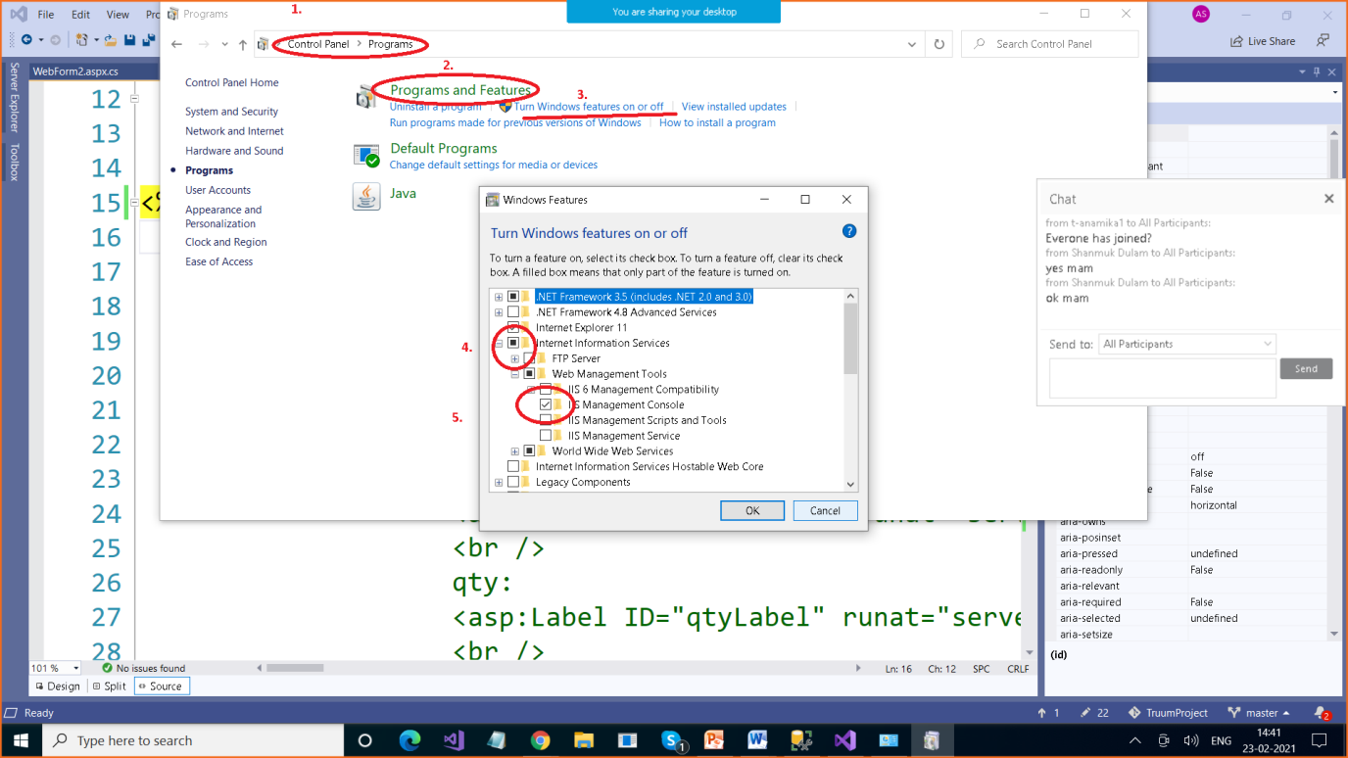

To check type inetmgr in Search pane